Understanding of Hardware and Its Components

QUESTION:1 Which of the following is NOT a component of the CPU?

ANS: Ram

QUESTION:2 What is the function of RAM in a computer?

ANS: RAM is main part of computer. It’s give better performance during multitasking any other task or operation. RAM gives temporary storage and faster then other types of storage.

QUESTION:3 Which of the following is a primary storage device?

ANS: hdd and sdd both

QUESTION:4 What is the purpose of a GPU?

ANS: GPU means graphics processing unit. It’s handle and accelerate and rendering images,animation and videos for display.

QUESTION:5 True or False: The motherboard is the main circuit board of a computer where other components are attached.

ANS: TRUE

QUESTION:6 True or False: A UPS (Uninterruptible Power Supply) is a hardware device that provides emergency power to a load when the input power source fails.

ANS: TRUE

QUESTION:7 True or False: An expansion card is a circuit board that enhances the functionality of a component.

ANS: FALSE

QUESTION:8 Explain the difference between HDD and SSD.

ANS:  **HDDs** are generally larger and more cost-effective for bulk storage but are slower and more prone to failure, while **SSDs** are faster, more durable, and consume less power.

QUESTION:9 Describe the function of BIOS in a computer system.

ANS: the BIOS is crucial for starting up a computer, checking hardware integrity, and providing a means to configure system settings. It acts as a bridge between the computer's hardware and the operating system,

QUESTION:10 . List and briefly explain three input devices commonly used with computers.

ANS: keyboard-Keyboards are essential for typing documents, entering data, programming, and executing commands in various applications

Mouse- used for selecting items, navigating menus, and executing commands by pointing and clicking.

Scanner- used for digitizing paperwork, archiving documents, or converting printed images into digital files for further processing or sharing.

QUESTION:11 . Identify and label the following components on a diagram of a motherboard: ● CPU ● RAM slots ● SATA connectors

ANS: 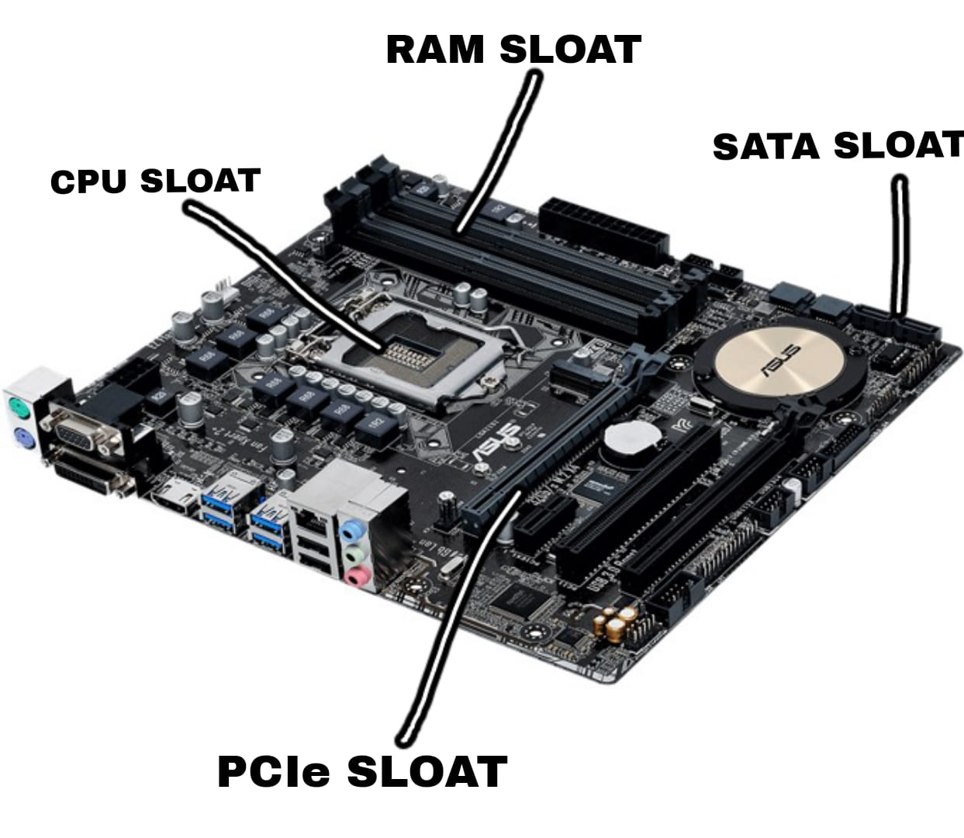

QUESTION:12. Demonstrate how to install a RAM module into a computer.

ANS: Installing RAM is relatively simple. Always ensure you handle components carefully and verify that the computer recognizes the new memory after installation. If you encounter any issues, double-check that the RAM module is properly seated and that it’s compatible with your motherboard.

QUESTION:13. Discuss the importance of proper cooling mechanisms in a computer system. Include examples of cooling methods and their effectiveness.

ANS: preventing overheating,maintain performance, extending component lifespan, stability and reliability, noise reduction.

There are some cooling method:

Air cooling

Liquid cooling

Heat sink

Thermal paste

Case fans

QUESTION:14. Explain the concept of bus width and its significance in computer architecture.

ANS: bus width is a fundamental concept in computer architecture that significantly impacts data transfer rates, system performance, memory addressing, and overall computing capability. Understanding bus width helps in designing and optimizing computer systems to meet the demands of modern applications and workloads. A wider bus typically leads to better performance, making it a critical consideration in both hardware design and system architecture.